ULTIMATE FRISBEE AND
SOCIAL EMOTIONAL LEARNING
Valerio Iani, Bay Area Disc Association – Program Director, Youth and Education
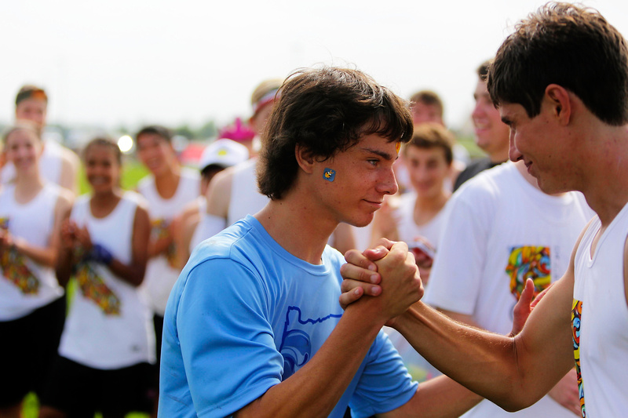

SESSION CONTENT

MAIN POINTS
Educators will learn about Ultimate Frisbee, a new sport that will be attractive and enjoyable for their students. One of Ultimate’s unique features is that it is self-officiated, placing on kids the responsibility for their conduct and decision-making without delegating this to referees. The resulting emphasis on personal accountability, empathy and communication makes Ultimate a powerful learning tool by which youth develop important social emotional skills that are critical for all aspects of their lives.

According to the Collaborative for Academic, Social, and Emotional Learning (CASEL), “Social emotional learning (SEL) is the process through which children and adults develop skills needed to effectively manage themselves and their relationships with others.” All five SEL competencies – self-awareness, self-management, responsible decision-making, relationship skills, and social awareness – are in action in the sport of Ultimate.

Consider the words of Lauren Casey, a Stanford grad who won two world Ultimate championships and six national championships, regarding the experience of playing Ultimate: “You have to learn to calm your temper. You have to learn to communicate. You have to learn to empathize. You are expected to self regulate. You are expected not to cheat. You are expected to respect your opponent in that they are not cheating.” These elements of the game embody the values we are teaching young kids every time they step on the Ultimate field.

At Bay Area Disc Association, we see how Ultimate, with its foundation on social emotional learning, is uniquely suited to building and shaping young characters. We are working to highlight SEL in our curricula as well as create and support programs in Bay Area schools that teach SEL through Ultimate.

GOAL: Learn responsibility and conflict resolution, learn the self-officiating Ultimate game.

LEARNING OUTCOMES: After this session, educators/participants will learn the basic rules of Ultimate and will be able to run a self-officiated game with their students.

“Ultimate experience”
"The integrity of Ultimate depends on each player's responsibility to uphold the Spirit of the Game, and this responsibility should remain paramount." - The Official Rules of Ultimate 11th Edition
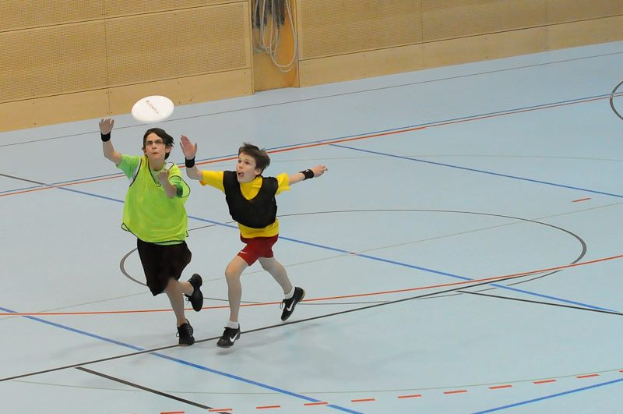
Self-officiating rules of the game: Ultimate is a very intuitive sport but when introducing the self-refereeing system it is fundamental to provide simple, clear, and precise basic guidelines and key rules. This enables new players to start playing as soon as possible, develop play continuity, respect opponents, reduce conflict, experience firsthand the effectiveness of self-officiating, and consequently enjoy themselves with a considerable improvement in self-esteem level. Emphasize Spirit Of The Game will creates an environment that fosters good behavior.

Players should make a 'call' verbally indicating the rule that was broken (self-awareness). All players must stop moving. The opposing player may ‘accept’ or 'contest' the call (self-management). Players should be encouraged to come to a resolution (relationship skills) about a call as described below.
Whenever there is a disagreement over ‘accepting’ or ‘contesting’ a call, for instance a player insists s/he incidentally touched a receiver rather than fouled them, send the disc back to the last thrower, allow the defense to ready itself, and then resume play. Fair and quick resolution of calls is considered 'good spirit’ (social awareness). A player may always retract a call that s/he has made if, upon reflection, their call was incorrect. (responsible decision-making)

At the end of each game teams form the Spirit Circle, a traditional ritual that pushes the boundaries of physical and verbal interaction to a deeper level beyond the default “good game” and high five. It is a special moment that brings opposing players together, reduces post-game frustration, and facilitates communication.

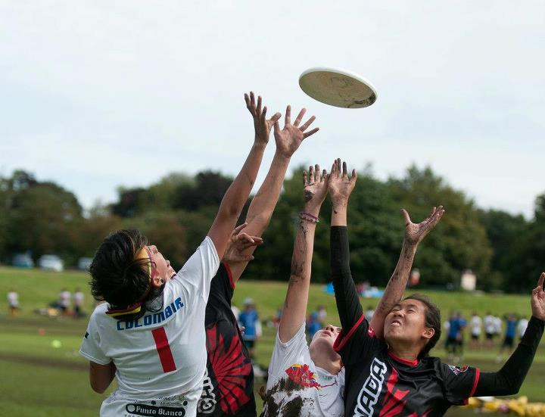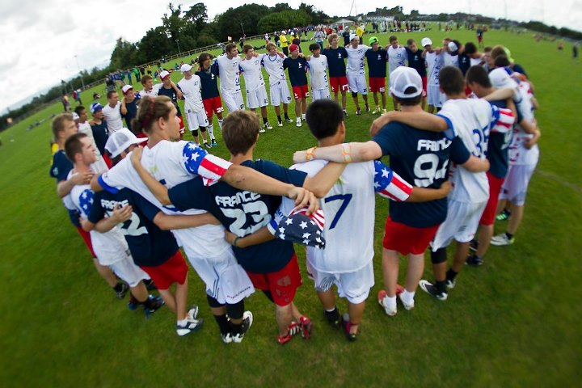
Spirit Of The Game - http://wfdf.org/sotg/about-sotg
“Ultimate relies upon a spirit of sportsmanship that places the responsibility for fair play on the player. Highly competitive play is encouraged, but never at the expense of mutual respect among competitors, adherence to the agreed upon rules, or the basic joy of play.”
By putting officiating, game management and team conduct in the hands of its players, Ultimate teaches responsibility and fair-play. This code of conduct is called the “Spirit Of The Game“.
“It is assumed that no ultimate player will intentionally violate the rules; there are no harsh penalties for inadvertent infractions but, rather, a method for resuming play in a manner which simulates what would most likely have occurred had there been no infraction.” - The Official Rules of Ultimate 11th Edition

Not only can students get great exercise and have fun playing Ultimate, they will learn character building values. Ultimate is the perfect context for teaching good sportsmanship, respect for opponents and leadership.

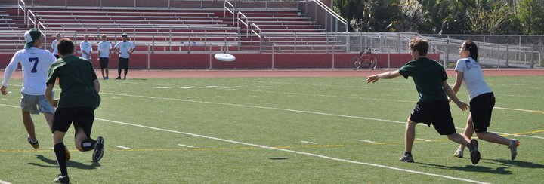WHY ULTIMATE IN YOUR SCHOOL?
Ultimate meets and exceeds the standards of what your school curriculum desires from an athletic program and has important characteristics that make it ideal for schools:
Educational – Ultimate is a self-officiated sport and it embodies the central tenets of Social Emotional Learning (SEL) and has great potential to build and shape young characters.
Coed – Historically a coed sport where girls and boys play together even at the highest levels, Ultimate offers equal opportunity for girls and boys especially because disc skills can offset athleticism and evan at the highest level there is a specific Mixed division (4:3/3:4 gender ratio).
Inexpensive – You can play anywhere, with minimal equipment; the game is simple and straightforward: two teams, a field and one disc. Its self-officiated system dispenses with the cost and additional organization that other sports require in order to provide referees.
Safe – Ultimate is a non-contact sport where non-incidental contacts are fouls and a ‘disc space’ between players is required at all times. Actions such as taunting opposing players, dangerous aggression, intentional fouling, or other ‘win-at-all-costs’ behavior are contrary to the Spirit Of The Game and are actively discouraged.
Inclusive – As a team sport where you literally cannot advance the disc without someone else to throw to—Ultimate is a great tool for building cohesion and teamwork. Ultimate promotes a culture of valuing all of its members and being inclusive by gender, race/ethnicity and levels of mental and physical ability.

ULTIMATE OVERVIEW
Ultimate, also known as Ultimate Frisbee, is a fun, challenging, inclusive team sport. Ultimate was invented in the late ’60s and today is played in over 60 countries around the world. The World Flying Disc Federation was granted full recognition by the International Olympic Committee in 2015 and Ultimate was recently named the fastest growing team sport in America by the Sporting Goods Manufacturer Association (SGMA). In the US nearly 1 million people play the game. Competitive level players, who are members of USA Ultimate, number 50,000, with youth members outnumbering adult members for the first time since the sport began in 1968.
International, national and local organizations
USA Ultimate, a non-profit organization founded as the Ultimate Players Association (UPA) in 1979, serves as the National Governing Body for the sport of Ultimate in the United States. USAU is member of the World Flying Disc Federation (WFDF), which is a member of the General Association of International Sport Federations (GAISF) and the International World Games Association (IWGA). USAU annually sends multiple National Teams to represent the United States at a variety of international events, including the World Games, which operates under the patronage of the International Olympic Committee (IOC). - www.usaultimate.org
Bay Area Disc Association is a non-profit founded in 2008. The mission of Bay Area Disc Association is to foster good sportsmanship by teaching and providing opportunities to play the sport of Ultimate throughout the San Francisco Bay Area. We believe that Ultimate's spirit of good sportsmanship, in which players self-officiate, can provide a model for individual and social responsibility. We focus on promoting the growth of Ultimate amongst adults and youth while simultaneously raising funds for nonprofit organizations in the communities it serves. - www.bayareadisc.org
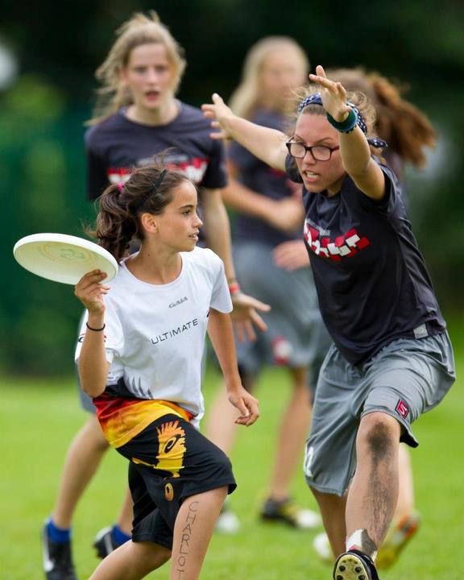
Ultimate at the middle and high school level
In California there are hundred of schools that are home to Ultimate programs, from informal club groups to competitive teams. Los Angeles and San Francisco are the most active areas. In the Bay Area alone there are more than 50 HS and MS teams. Berkeley, Alameda, San Mateo and Santa Cruz have solid and long-term programs.
Some premier youth events in California and on the West Coast include Seattle “Spring Reign” and Bay Area “Spaghetti Western” tournaments, the USAU Middle and High School State Championships and the USAU High School Western Championships.

Ultimate at the college level
There are ~15,000 student athletes playing on over 700 college Ultimate teams in North America, and the number of teams is steadily growing. Separated into Open (nearly 450 teams) and Women's (around 200 teams) divisions, teams compete in the USA Ultimate College Championship series during the spring.
In recent years some of the best teams, often national champions in the Open and Womens divisions, come from California: Claremont Colleges, UC Santa Barbara, Stanford University, UC Davis, UC San Diego and UC Berkeley.
Ultimate in California: the Berkeley’s Model
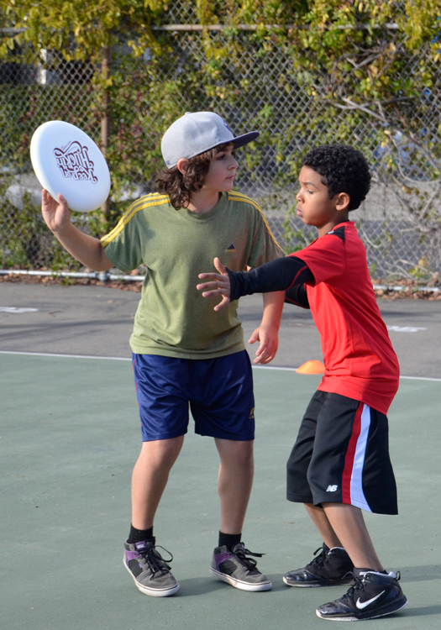  Malcolm X Elementary School  After-school Classes (scrimmages) | 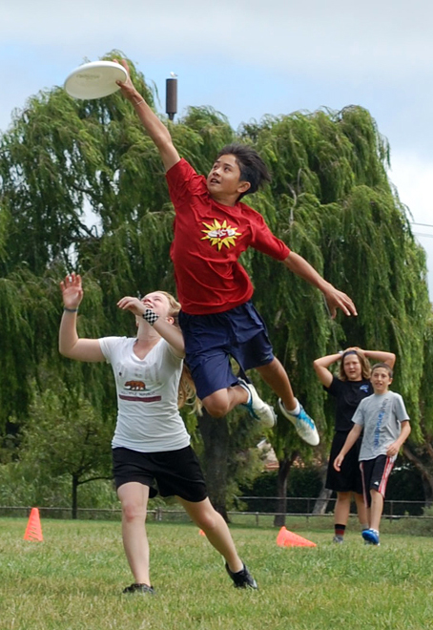  Willard and King Middle School  Coed Programs (leagues/MSSL, State Championship)
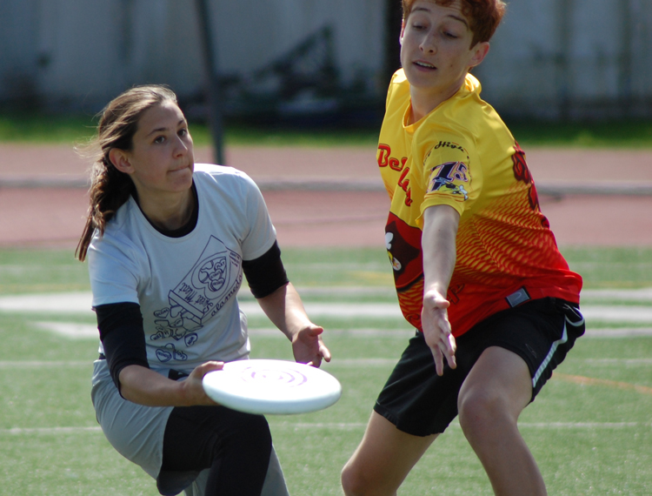  Berkeley High School  Club / PE Credit (leagues, State Championship) | 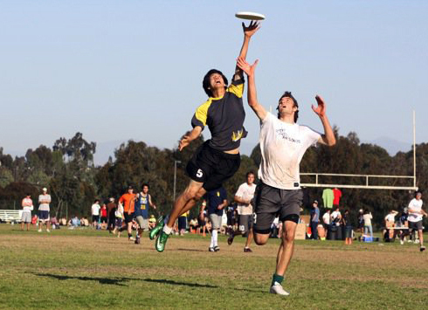  University of California  Open and Women Teams (College Championship)
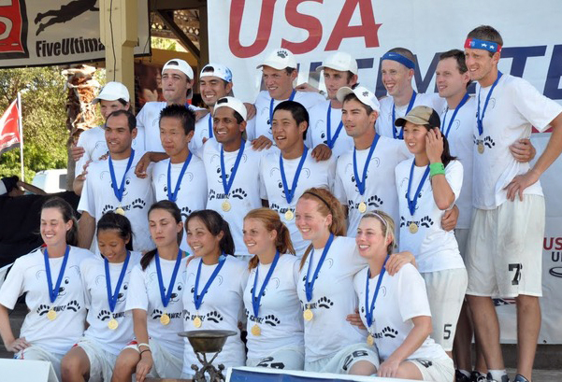
Bay Area Open, Women, Master and Mixed Club Teams
***World and National Ultimate Champs!!!***

