Song List
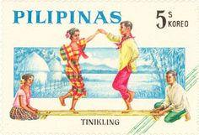
Here is a list of modern/hip-hop songs that can be used for Tinikling.
- Queen “We Will Rock You”
- Flo Rida “My House"
- 50 Cent “Disco Inferno” instrumental
- Silento “Watch Me (Whip/Nae Nae)”
- Kids bop “The Lazy Song”
- One Direction “History”
- Skrillex & Damian Marley “Make It Bun Dem”
- Chipmunks “No One”
- Justin Timberlake “Not a Bad Thing”
- Ester Dean “Take You to Rio”
- Winston Riley “Bam Bam”
- Fergie “Clumsy”
- Taylor Swift “Bad Blood”
- Chris Brown “Loyal”
- The Weekend “Can’t Feel My Face”
- Nick Jonas “Levels”
- Chipmunks “Witch Doctor”
- Pitbull “Back In Time”
- The Weekend “The Hills”
- Robin Thicke “Blurred Lines”
- Justin Bieber “What Do You Mean?”

