Directions: Scan the following QR pictures on a mobile device using a QR reader. The image will tell your mobile device where to find the corresponding video.
Tinikling Unit
Tinikling Unit

- Open The App on your Mobile Device
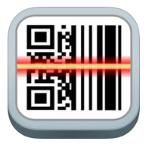

2. Scan the QR code with the app
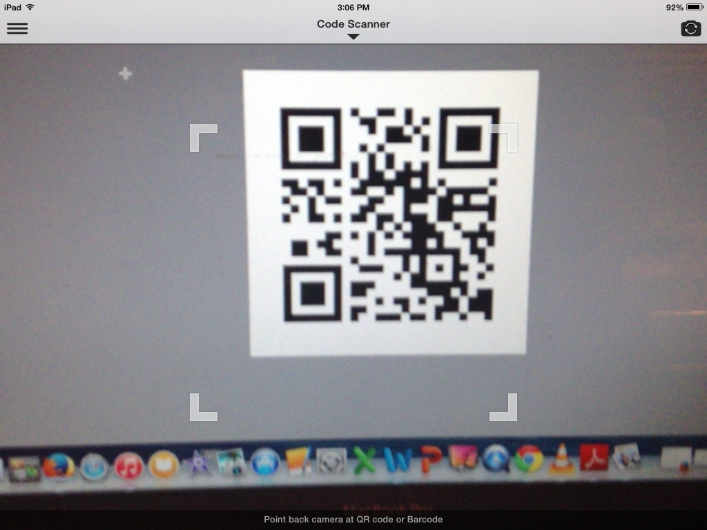

Get the QR code inside the square corners

This unit is a self-paced unit. You will work in your small group and progress through each lesson. Make sure you take the time to master each step before progressing to the next step. When you are finished learning all of the Tinikling Dance steps, you should prepare for your assessment. The assessment will require the student to combine the different dance skills into a routine.

Use the provided footprints to help you see how you should move during the skill. Use the QR codes to watch a video demonstration of the same skill. The assessment will incorporate numerous steps into one routine.

Basic Progression
- Work on the steps without the poles moving
- Work on the steps with the poles moving slowly
- Work on the steps with the poles moving at traditional speed
- Work on the steps by combining the same steps 4 (or more) times in a row
- Work on the steps by combining the dance step with a basic step (Master before moving to the next one)
Tinikling Unit

Tinikling Introductions (Background & Basics)
Filipino Dance
Mimics the Tinkling Bird

Clapping 101
Down, Down, Together (Clap, Clap, Slide)
Down, Down, Together (Clap, Clap, Slide)
Slide your poles together on the ground
The Basic SteP

The Basic Step
Starting on Left:
Right (In), Left (In), Right (out), Left (up)
Starting on Right:
Left (In), Right (In), Left (out), Right (up)

Mastery:
1) Be able to perform 4 consecutive basic steps in a row without making a mistake.

180-DEGREE Turn
In-In-Out

In-In-Out
Both Feet In-Both Feet In-Both Feet Straddle Poles

Mastery:
1) Be able to perform 4 consecutive In-In-Out steps in a row without making a mistake.

180-Degree Turn
Right Twist (In), Right Twist (Turn), Left Foot Out (Lift Right)
Left Twist (In), Left Twist (Turn), Right Foot Out (Lift Left)

Mastery:
1) Be able to perform 4 consecutive 180 Degree Turn steps in a row without making a mistake.
Angle Step

Angle Step
Half Basic
Travel at a 45-degree angle across poles
Same steps as Basic but at 45-degree angle

Mastery:
1) Be able to perform 4 consecutive angle steps in a row without making a mistake.

Half Basic
Left Foot In (twist), Right Foot In (together), Left Foot Out

Mastery:
1) Be able to perform 4 consecutive half basic steps in a row without making a mistake.
Full Uprock

Full Uprock
Tic tock
Easiest to start Left In, Right Out (two step)
Left (In), Right (In), Left (Out)

Mastery:
1) Be able to perform 4 consecutive Full Uprock steps in a row without making a mistake.

Tic Tock
Left/Right Running Motion, Out (straddle)

Mastery:
1) Be able to perform 4 consecutive Tic Tock steps in a row without making a mistake.

Sponge Bob

Sponge Bob
Hop Skotch
Left Foot, Kick Out
Right Foot, Kick Out

Mastery:
1) Be able to perform 4 consecutive Sponge Bob steps in a row without making a mistake.
Small Pause

Hop Skotch
Both Feet In, Pause, Both Feet Out (straddle)

Mastery:
1) Be able to perform 4 consecutive Hop Skotch steps in a row without making a mistake.

TINIKLING Red ASSESSMENT
TINIKLING ASSESSMENT

Directions: You will need to practice a Tinikling routine for your assessment. This assessment must be completed in a partnership (i.e. Two students will assess at the same time, performing the same routine). You have been given the choice to demonstrate one of three routines. PICK ONE! Practice the same routine over and over again.

After you have practiced the routine, use one of the mobile devices from your teacher and video tape yourself. Analyze the video to make sure that you have memorized the dance, the steps are correct, and that your timing is well rehearsed.

Continue to practice your routine. When you have memorized your routine and can perform it without a mistake, ask the teacher to assess you.

RED Assessment: Basic Steps
White Assessment: Basic Steps + a challenging step
Blue Assessment: More challenging, add in your own step

 | Option #1 (Partners start on opposite sides)
1 | Basic | Basic Step
2 | Angle Step | Angle Step
3 | Angle Step | Angle Step
4 | Half Basic | Half Basic
5 | 180 Degree Turn | 180 Degree Turn
6 | 180 Degree Turn | 180 Degree Turn
7 | Half Basic | Half Basic
8 | Basic | Basic
9 | In-In-Out | In-In-Out
10 | In-In-Out | In-In-Out

TINIKLING White ASSESSMENT
WHITE Assessment

 | Option #2 (Partners start on same side)
1 | In-In-Out | In-In-Out
2 | In-In-Out | In-In-Out
3 | Basic | Basic
4 | 180 Degree Turn | 180 Degree Turn
5 | Half Basic | Basic (different than partner)
6 | Angle Step | Angle Step
7 | Angle Step | Angle Step
8 | Basic (different) | Half Basic
9 | Full Uprock | Full Uprock
10 | Full Uprock | Full Uprock
TINIKLING Blue ASSESSMENT
BLUE Assessment

 | Option #3 (Start on opposite sides)
1 | Basic | Basic
2 | Full Uprock | Full Uprock
3 | Full Uprock | Full Uprock
4 | Half Basic | Half Basic
5 | Angle Step | Angle Step
6 | Angle Step | Angle Step
7 | 180 Degree Turn | 180 Degree Turn
8 | Pick One | Pick One
9 | Pick One | Pick One
10 | Basic | Basic

Pick one of the following dance steps for #8 & #9:
* Tic Tock
* Sponge Bob
* Hop Skotch
TINIKLING ASSESSMENT

 | Fantastic  3 Points | Good  2 Points | Fair  1 Point
Dance Steps | Team demonstrates 5 dance steps correctly | Team demonstrates 3-4 dance steps correctly | Team demonstrates 0-2 dance steps correctly
Routine is Practiced | Both partners know the routine | Only one partner knows the routine | Neither partner knows the routine
Rhythm | 0 Mistakes Made | 1-3 mistakes made | More than 4 mistakes made

Grading:
Proficient (100%): 8-9 points
Approaching Proficient (85%): 6-7 points
Developing (75%): 5 points and below
Beginning (0%): Did not take assessment

