Tinikling Quiz
(_____/22 points)
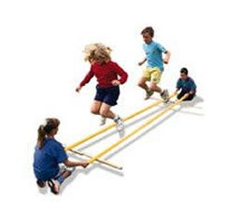
- Where does Tinikling originate from? (1point) ________________________________
- How many counts is each step? (1point) _____
- How many people does it take to do a routine? (minimum) (1point) __________
- The word Tinikling comes from what type of animal? (3 points) _______________
  - Why? ________________________________________________________________
______________________________________________________________________
______________________________________________________________________
- The correct movement pattern of the poles are: (1 point)
  - Slap, Slap, Clap
  - Slap, Tap, Slap
  - Clap, Clap, Slap
  - Slap, Clap, Slap
- The poles should be on my _______________________ side when I begin the basic step. (1 point)
- The _________________________________ is when you start with the poles on your right side. I jump in poles with both feet twice and then Jump and ½ turn with both feet outside of the poles. I then jump with both feet outside poles twice, and then jump and ½ turn with both feet outside poles. (1 point)

- Name the other four steps and explain which side the poles should be on and how to perform the step. (8 points)
  - _______________________________________________________________________
_______________________________________________________________________
_______________________________________________________________________
  - _______________________________________________________________________
_______________________________________________________________________
_______________________________________________________________________
  - _______________________________________________________________________
_______________________________________________________________________
_______________________________________________________________________
  - _______________________________________________________________________
_______________________________________________________________________
_______________________________________________________________________
- What’s the minimum amount of people you would need to perform the 4 stick Tinikling? (1 point) _____
- Create a dance routine consisting of at least 32 counts (4 points)
_______________________________________________________________________
_______________________________________________________________________
_______________________________________________________________________
_______________________________________________________________________
_______________________________________________________________________
_______________________________________________________________________

