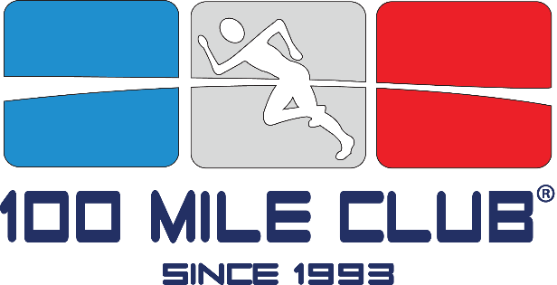

The 100 Mile Club:
An Award Winning Program Combatting Childhood Inactivity

Presented by
Kara Lubin
Founder and CEO

Kara Lubin is founder and chairman of 100 Mile Club. Kara started as a special-education teacher who had a classroom full of students who couldn’t sit still. Lubin started small, asking her kids to run every morning for 10 minutes. She noticed a difference in their behavior within a week; her classroom was full of more engaged and focused kids. Now, 24 years later, the organization has reached over 1000 schools nationwide. Featured in Runner’s World Magazine in January 2013, and recognized by ChildObesity180 as having one of the most scalable and innovative physical fitness programs in the United States, The 100 Mile Club’s mission remains the same; reach one child, one school, and one community at a time, instilling fitness and a healthy lifestyle. Kara and her husband Glen, a school administrator, live on a little ranch in Norco, California with their 2 children, Paris and Millie.

