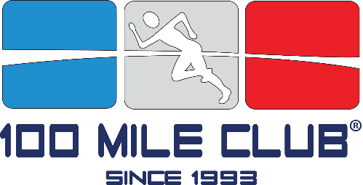

Inspired by the 1992 Olympics, special education teacher Kara Lubin used the dream of becoming a gold medalist to inspire her hard-to-motivate students. That year, The 100 Mile Club was born from a simple idea, run 100 miles and earn a medal. With incentives given along the way, including our unique milestone t-shirt, lessons in goal-setting, determination, and team spirit are delivered alongside exercise.
Despite this growth, its sole purpose remains unchanged: improve the health and well-being of children at school through daily physical activity in a noncompetitive, supportive, and inclusive environment.

Some Interesting Facts
- Active kids do better: better in the classroom - better attendance - better health and fitness.

- Rather than compete against each other, students at participating schools are members of the 100 Mile Club “team”, where every student has the opportunity to be successful.

- Whether they run, jog, or walk towards their goal, the 100 Mile Club inspires students of varying abilities – athletic, non-athletic, learning disabled, handicapped - to be active in an accepting, positive environment.

- We provide children with hope, camaraderie, and the knowledge that they can be successful in school and beyond.

- We address childhood obesity and inactivity using a safe and consistent program that can be modified to fit the needs of all children.

- Today you can find us in every state and in several countries too!

Awards and Recognition

- 2012 National winner (one or two) of The Active Schools Acceleration Project (ASAP) competition which identified and rewarded the most creative, impactful, and scalable school-based programs to promote children's physical activity. With encouragement of First Lady Michelle Obama, ASAP is committed to reversing the trend of childhood obesity.

- 2010 California Governor’s Council on Physical Fitness and Sports: Spotlight Award, Gold Medalist, Non-Profit Organization of the Year.

- 2010 Spirit of the Entrepreneur Award/Inland Spirit Awards: Social Entrepreneur of the Year.

- 2013 – Featured in Runner’s World Magazine

