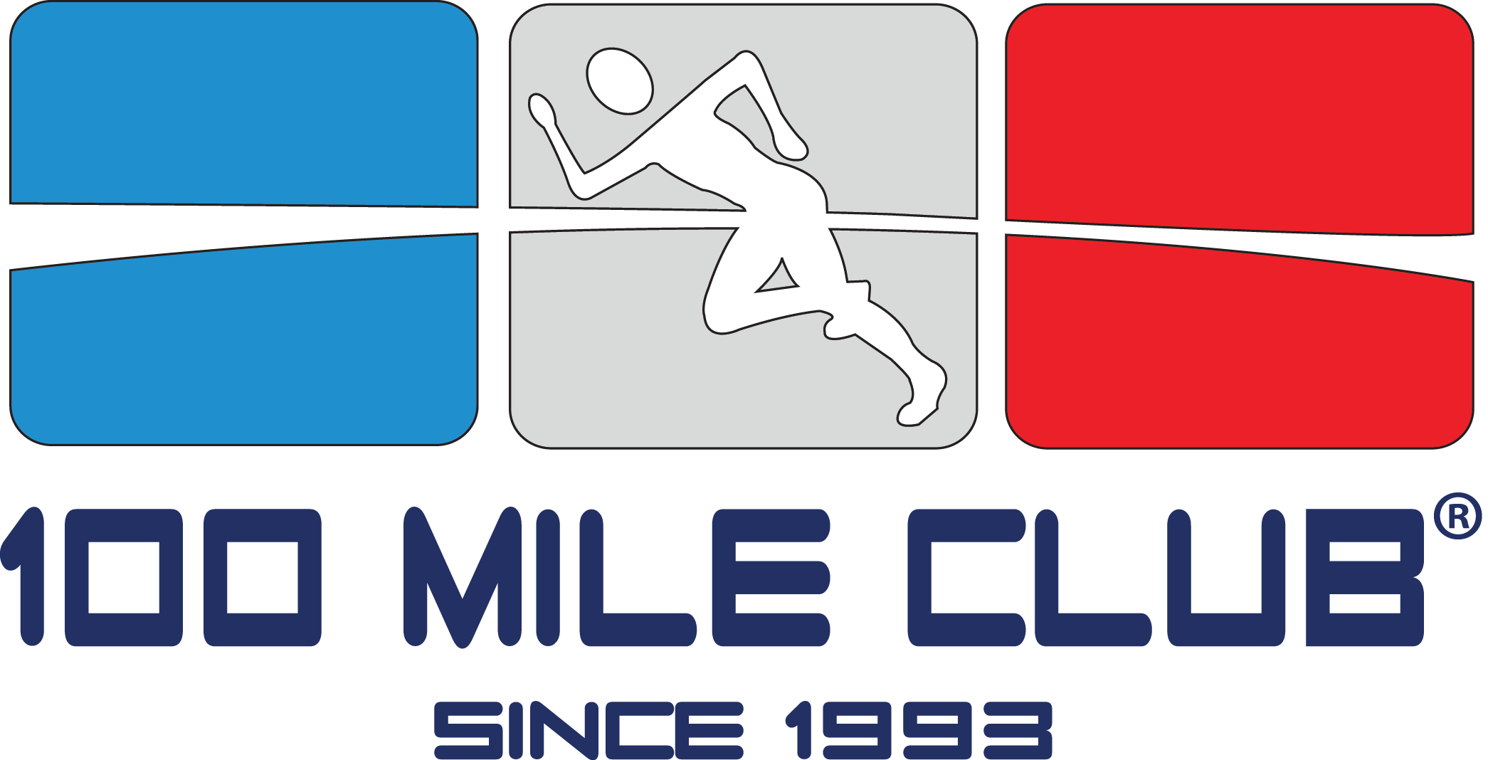Welcome to the 100 Mile Club!

We are excited and honored to welcome you to the 100 Mile Club® Family! My name is Kara Lubin, and I started The 100 Mile Club in my classroom 24 years ago.
I am a fourth-generation public school teacher and served as a Special Education Specialist in Southern California for over 18 years. I began The 100 Mile Club during the 1992-93 school year, my second year as a classroom teacher. The amazing students in my class were diagnosed with various learning disabilities and they were also extremely, extremely energetic! Some of the students were diagnosed with ADHD, some had behavior disorders, some were uninspired and angry, and some just didn’t want to be at school at all. None of them had ever experienced any sort of success at school. Can you imagine coming to school every day and never feeling like you were good enough? I’d be uninspired and angry, too!
We were losing these kids, fast. The task was overwhelming.
How would I teach these amazing children?
How could I teach them what success looked like, felt like…how could I teach them to seek success at school if they had no idea what it was?
How could I calm, center, inspire, and energize them all at the same time?
In a day hopelessly filled with CAN’Ts, how can I give them a CAN?
We were in an Olympic year, and the 1992 Summer Olympics were incredible! The Dream Team, the Track & Field events and inspiring stories of triumph and tragedy were fresh on their minds and mine. I was truly inspired! The universal dream of becoming a gold medalist was the catalyst and that year, The 100 Mile Club was born from a simple idea: run 100 miles and earn a gold medal, just like the Olympians. My students embraced the challenge.
Encouraged by family friend, John Wooden, and his famous Pyramid of Success, I developed the program and capitalized on its immediate effects… calmer, more focused and motivated learners. That year, I designed a shirt using puffy paint and clearance-rack tees to serve as the students’ “incentive chart” which they only received after logging 25 miles, and further reinforced the value of their perseverance by awarding to each student a golden pencil at 50 miles and a wristband at 75. All students received a certificate of completion no matter the miles earned and those who met their 100-mile goal received a beautiful gold medal, awarded at a special year-end medal ceremony. The value of these simple tokens exceeded all expectations and celebrated milestones met of new confidence, poise, increased physical fitness levels and self-esteem for my students. It worked!
Some students finished their 100 miles, some went far beyond 100 miles, and some students didn’t quite get there. All of my kids had one thing in common though: They all gave their personal best during this 100-mile journey, and they learned what their personal best looked (and felt) like. They became a team, loved coming to school, took care of one another, and celebrated one another every single day. It was amazing.
The 100 Mile Club quietly evolved in my classroom. Not only did my students consistently score higher on physical fitness tests than their non-disabled peers, they also showed improved attendance, academic achievement, and behavior. In 2008, 100 Mile Club went viral, literally doubling in size almost every year since then, and has earned both local and national recognition. Despite this growth, our sole mission remains unchanged: improve the well-being of children at school through daily physical activity in a noncompetitive, supportive, and inclusive environment.
For the last 24 years, The 100 Mile Club has been part of my world. Now, it is going to be part of yours and I couldn’t be more thrilled. When you are part of 100 Mile Club, you are part of a close family of teachers, parents, administrators, and coaches who help ALL kids be the very best they can be. We are always just a phone call or click away.
Change happens one child, one school, one community at a time, and you are the catalyst. YOU are Coach. We couldn’t be more thrilled! Congratulations and welcome once again.
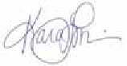
Yours,

Kara Lubin, Founder
The 100 Mile Club

