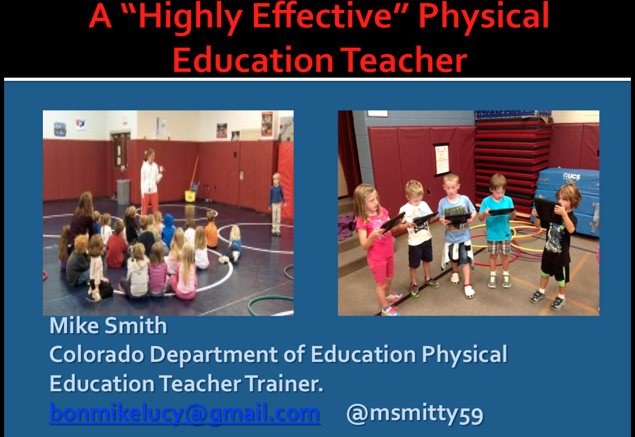

Here is the link to my handouts for this session.
http://scan.me/6ptcg87

