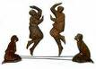
Forward Basic
- Face poles and hop in with right foot
- Hop in with left foot
- Hop out with right, lift left
- Pause

- Hop back left into poles
- Hop back right into poles
- Hop out left, lift right
- Pause

